I
nformer
The
October 2018 Edition
Saint James Presbyterian Church, U.S.A.
820 Ross Avenue, Greensboro, NC 27406 · 336-273-6658 · www.stjamespresby.org
“Touching Lives Through Jesus Christ!”
Reverend Eustacia Moffett Marshall, Supply Pastor
Welcome To Saint James Presbyterian Church!
The members of the Saint James Presbyterian Church are pleased to have you worship with us during the month of September. We ask that you kindly complete a guest card, found in the pew, and give it to a Deacon or Usher or place it in the offering plate. We would like to have a record of your visit and a way to keep you updated on what is happening here at Saint James. Your information will remain confidential. If you have children ages 3 months to 6 years old, feel free to ask a Deacon/Usher about our Nursery!

Are you interested in joining Saint James?

We welcome you to join Saint James Presbyterian Church and are committed to helping you grow as a disciple of Jesus Christ. You may become a member of the Saint James Presbyterian Church in one of the following ways: (1) come forward during the invitation; (2) complete a guest card and place it in the offering plate during the offering, or (3) contact the church office during the week (9:30 a.m. – 5:30 p.m. Mon - Fri). We look forward to helping you make this decision.

Connect With Us!

Like us on Facebook: www.facebook.com/stjamespresby

Follow us on Twitter: @stjames_gsonc

Saint James Wi-Fi: Touching Lives
Password: TouchingLives (case sensitive, no space)

Our Purpose Statement:
“The purpose of Saint James Presbyterian church is to touch lives through Jesus Christ by providing joyful worship, life changing teaching, warm community, and dynamic, meaningful ministries that serve to bring a new generation of believers to Christ and to nurture those who are already growing in faith.”
In This Issue

Welcome 1
Visitor Information, Social Media, WiFi Access, Purpose Statement 1
Worship 3
Fall Schedule, Order of Worship Service & October Participants 3
October Preaching Path 4
Mid-Week Schedule 5
Discipleship 5
Milk & Honey Café, Sunday School, Bible Studies 5 Presbyterian Women Bible Study Circles 6
Presbyterian Women 7
Presbyterian Men 8
Presbyterian Men, Older Adult Ministry 9
Administration 9
Car Wash Gift Cards, Informer Deadline, Trustee Board 9
Session Ministry Assignments 10
Evangelism 10
New Members & Inquirers Class, Who Are You Inviting… 10
Faith Point Fellowship (FPF) 10 Soul Food Conversations Bible Study, Thirsty Thursday 11
FPF Prayer List 12
Forget Me Not List 13
Fellowship 14
Thank You 14
Outreach 14
Message & A Meal 14-15
Hurricane Relief 15
Adopted School, Tiny House, Health Fair, Crop Walk 16
Stewardship 17
Upcoming Events 18
Voting/November Election 18
Volunteer Corner 19
Audio/Sound, Evangelism, FPF, Hand bells, Nursery, Office, Outreach, Ushers 19
Church Schedule 20
Kids Korner 21-22
Notes 23-26

WORSHIP Saint James worship services & shared community worship opportunities.
Fall Schedule: Join us for 8:00 am Express Service or 11:00 am for Morning Worship each Sunday. Holy Communion will be served on first Sundays during both services. Individual tapes and CD’s are available for purchase every Sunday for $5.00 or purchase 4 tapes/CD’s for $15.00. See a member of our Audio/Visual Team in the Narthex to make a purchase.

Standard Order of Worship:
Welcome
*Opening Hymn
*Call to Worship
*Praise & Worship
Opening Prayer
Welcome Guests
Minute for Mission
Liturgical Arts
Offering, Offertory Prayer & Music
Mission Opportunities
*The Apostle’s Creed
Pastoral Prayer
Special Music
Prayer of Illumination
*Scripture Reading
Sermon
Invitation to Christian Discipleship
*Invitational Hymn
Holy Communion on First Sundays
*Recitation of the Saint James Purpose Statement
*Benediction & Amen
Ocotber Participants:
Worship Leaders:
Reverend Eustacia Moffett Marshall
Deacon Donald Miller

Music Directors:
Ms. Jasmine Evans, New Generation Praise Team & Inspirational Ensemble
Ms. Valerie Johnson, Chancel Choir & Combined Choir

Musicians:
Dr. Ronald Campbell, Organist & Keyboardist
Mr. Nick Hayes, Percussionist
Mr. Terry McCluney, Guest Percussionist
Mr. Melvin Turner, Guest Percussionist

October Preaching Path

Let’s continue reading together! As we journey into the month of July, let us prepare our hearts and minds for worship by reading the scheduled lectionary texts each week. The texts are listed below. Before you read each text practice a few minutes of centering prayer to clear your mind. Pray for clarity and focus. While reading, physically or mentally take notes so that you can summarize what the scripture is saying. Finally, go back and pick out any themes or recurring ideas that may be relevant to your personal life, Saint James or the church at large. Close your reading time with a Prayer of Thanksgiving for God’s word and revelation.

WORSHIP Saint James worship services & shared community worship opportunities.
Mid-Week Prayer Service is held every Wednesday at 12:30 pm. Come out and join members and friends for prayer and devotion. Teams responsible for leading for August and September 2018 are as follows:

October 3rd: Homeless Committee November 7th: Vacant
October 10th: Stephen Ministry November 14th: Inspirational Ensemble
October 17th: Monday Morning Class November 21st: NO SERVICE
October 24th: Estelle Eaton Circle November 28th: Sunday School
October 31st: Grace Brown Circle November 30th: Session

DISCIPLESHIP Sunday School, Bible Studies & Leadership Trainings

The Milk & Honey Café
Sunday Continental breakfast through the Milk & Honey Cafe will resume after kitchen renovations are completed.

Sunday School is available for all ages. Morning assembly begins at 9:15 am in the Sanctuary.

Monday Morning Bible Study welcomes all Saint James members to attend this class on Monday’s from 10:00 am to 11:00 am in Classrooms 1 & 2.

Wednesday Evening Bible Study will resume on Wednesday, October 3rd, at 6:30 pm. An announcement will be made in the near future with more details.

Thursday Evening Bible Study for college students and young adults ages 18 – 35 is hosted by Faith Point Fellowship at 6:15 pm in the J.T. Douglas Fellowship Hall. See page 11 for more information.
Presbyterian Women Bible Study Circles
The Essie B. Meares Circle will meet at noon on Saturday, September 15, 2018, in the J. T. Douglas Fellowship Hall. Mrs. Julia Ruth Richmond will start us with the introduction to our Bible Study and host our Annual luncheon. Remember to bring your handbook to all meetings. Visitors are welcomed.
Helen Branson, Moderator

DISCIPLESHIP Sunday School, Bible Studies & Leadership Trainings

Presbyterian Women Bible Study Circles
The Marie Florance Presbytettes Circle will meet on Sunday, October 21, at 2:00 pm. Our hosts will be Portia Griffin and Annetrice Hewitt. Location of the meeting is TBD. Ina Siler will lead Lesson 1 and Timisha Corpening will lead Lesson 2 from our bible study workbook, God's Promise: I Am with You. We will collect our Circle dues of $12.00 at this meeting. If you have not paid for your workbook, please bring your payment of $10.00. We always welcome visitors to our meetings. If you would like to attend or want to learn more about our Circle, please contact Ina Siler at 551-655-4612.
Ina Siler, Moderator

The Roxie McNair Circle will meet Friday, October 19, 2018, in Classrooms 1 & 2 at 1:00 pm. The agenda will include a discussion mission giving. We will discuss the second lesson of the PW/Horizon Bible Study God’s Promise: I am With You. All members are encouraged to read the lesson. All women are invited to attend.
Elder Pauline McNair, Moderator

The Sara Barber Circle will be hosted by Adnee Bradford and Aleta Bradford, 194 Wesley Harris Circle, Greensboro on Sunday, October 7, at 4:00 pm. Lesson 2, “God with Us in Our Uncertainty” from the study guide, God’s Promise: I Am With You, will be led by all circle members. Scripture: Exodus 3:1-12; Judges 6:11-27. Visitors are always welcome!
Linda Adams, Moderator

Presbyterian Women in the Congregation (PWC)
PWC Meeting will gather at 3:00 pm on Sunday, October 14, in the Sanctuary. The Estelle Eaton Circle will lead the devotion and Celebration of the Least Coin.

PWC Coordinating Team (CT) will meet on Thursday, October 11, 2018 5:30 pm in Classrooms 1 & 2. Moderators please make sure that your circle is represented. Search Committee Moderators please be present.

PW Bazaar Presbyterian women will host their Bazaar on Saturday, November 10, 10:00 am - 2:00 pm at the church. This is your chance to buy Christmas gifts from vendors selling handmade jewelry, soaps and other skin care products, wreaths, aprons, authors selling their books, tasty beverages, delicious Turkey BBQ from High Point, calendars, and many other products. We will have several tables with gently used household goods, personal accessories and homemade baked goods. Contact Dr. Ina Siler at 551-655-4612. If you want to be a vendor. To donate baked goods, contact Dr. Nan Manuel at 336-697-1735. To donate household goods, contact Mrs. Ann Purcell at 336-617-3514.
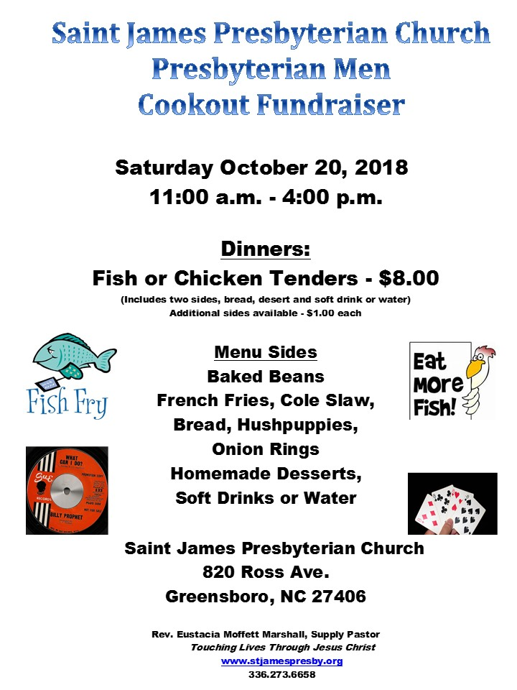DISCIPLESHIP Sunday School, Bible Studies & Leadership Trainings

Presbyterian Men
Cookout Fundraiser
Due to hurricane Florence the Men’s Cookout has been postponed and will take place on Saturday, October 20, 2018 from 11:00 am – 4:00 pm. All purchased tickets are still valid and additional tickets are available. Please see a member of Presbyterian Men to purchase your tickets today!

Volunteer with Presbyterian Men!
On the second Sunday of each month, available Men are asked to serve during Message and Meal and assist with the unloading of the Food Truck at 2:00 pm. Contact Elder Tyrone Collins to volunteer. Continue to pray for the Ministry as we seek to "Touch Lives Through Jesus Christ".

The Older Adult Ministry will meet October 24, 2018 at 1:15 pm immediately following Mid-Week Prayer Services. The ministry is sponsoring an open discussion about the six amendments on the ballot for the November 6, 2018, midterm elections and the voter ID laws. All super seniors of Saint James are encouraged to share in the discussion.
Mrs. Marie Martin

ADMINISTRATION Church Business & Officer Information
Car Wash Gift Cards For Sale!
Does your car need a little TLC? Is your car turning yellow from all of the pollen? Purchase a $20.00 Autobell Car Wash Gift Card today! These cards are a great way to invest in Saint James and to keep your ride sparkling in the spring sun. The Autobell Car Wash Gift Card is also an excellent card filler or gift to someone who loves a clean car. Contact the Church Office, Vanessa Haygood or Timisha Corpening to purchase your card today!

Monthly Informer Article Deadline
Please feel free to leave typed or handwritten articles in the Secretary’s Box in the Mailroom or e-mail: jevans@stjamespresby.org. Articles can be sent prior to the deadline with the subject: “November Informer.” The Final Deadline is Saturday, October 20, 2018 by 12:00 noon.

The Trustee Board will meet Sunday, October 20, at 12:30 pm in the NYDIA room.
Nancy Rives, Moderator

ADMINISTRATION Church Business & Officer Information
Session Ministry Assignments 2018
Administration:
Moderator Reverend Eustacia Moffett Marshall
Clerk of Session Elder Lynette Hawkins
Assistant Clerk of Session Elder Sharon Smiley
Personnel Elder Karen Watts-Yehudah
Treasurer Elder Timisha Corpening
Children/Youth Ministry Elders Robert Powell & Christina Yongue
Discipleship Elders Paula Graves & Channelle James
Evangelism Vacant
Fellowship Elders Tyrone Collins & Timisha Corpening
Financial Management Team (FMT) Elder Robert Powell
Stewardship Elders Karen Watts-Yehudah & Jerry Young
Ministry Elders Oscar Reid & Sharon Smiley
Worship Elders Sharon Gaskin & Gloria Tatum-Wade
Currently Unassigned Elder Robert Patterson

EVANGELISM Neighborhood blasts, New Members & Inquirers Class
New Members and Inquirers Class!
If you missed the last New Members and Inquirers Class or are interested in learning more about Saint James, contact the church office (336-273-6558) to sign up for the next class. We are looking forward to sharing more about who we are and what we believe!

Who are you inviting to church next Sunday?
Do you have a friend or family member that needs some encouragement? This month is a great time to invite a friend or co-worker to worship. Reach out to those around you offer them the chance to get what they need by inviting them to church.

FAITH POINT FELLOWSHIP Young Adult and College Ministry
Want to stay connected to Faith Point Fellowship? Text FPF to 55469 and receive words of inspiration and regular updates or visit our website at faithpointfellowship.org. We are also on social media @FaithPointFLWSP.

FAITH POINT FELLOWSHIP Young Adult and College Ministry
Soul Food Conversations is held every Thursday at 7:00 pm in the J.T. Douglas Fellowship Hall. Experience a different kind of bible study targeted to young adults 18 - 30 years old. We have fearless conversations around faith and everyday life. A FREE cooked meal is served at 6:15 pm. Meet our new interns. Invite a friend to experience this unique worshiping community. If you need a ride, call or text 336-690-8541 by 5:00 pm on Thursdays. Childcare is available.
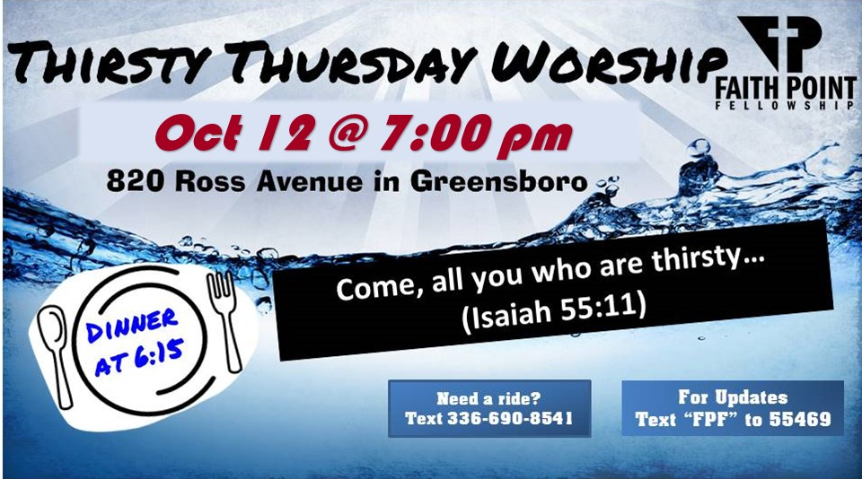
Thirsty Thursday Worship Service is moving to the second Thursdays! Our next worship service will be Thursday, October 11, at 7:00 pm in the Saint James Fellowship Hall. Rev. Eustacia Marshall will lead this dynamic and informal worship experience that includes music ministry presented by the Faith Point Praise Team. Millennials (18 - 40) and those who are young at heart are invited to attend this worship service. Free dinner is served at 6:15 pm. Childcare is available. If you need a ride, call or text 336-690-8541 by 5:00 pm on Thursday.

FAITH POINT FELLOWSHIP FORGET ME NOT LIST
Brooks Artis Clemson University
Emmale Burris Greensboro Technical Community College
Christian Butler NC A&T State University
Jordan Butler UNC-Greensboro
Andrea Cole UNC-Charlotte
Marcus Funderburk Forsyth Technical Community College
Micah Funderburk UNC-Pembroke
Kayla Gaskin Emory University
Jalen Graves UNC-Greensboro
Mia Graves East Carolina University
Ashley Halley Appalachian State University – Interning in Burlington
Brittani Hewitt Hampton University
Franklin McCain, III NC A&T State University
Brianna Mercer East Carolina University
April Newkirk Central Piedmont Community College
Alexis Robinson UNC-Chapel Hill
Isaiah Siler Greensboro Technical Community College
Jacquelyn Sullivan Guilford College
Matthew Watlington NC A&T State University
Shelleik Wilson Winston-Salem State University
FORGET ME NOT LIST Remember to pray for those who cannot attend worship

Pearl Booker 5533 Burlington Road,
McLeansville, NC 27301
Clarence and Pearl Durham 3313 Janet Lane, 27405
Bernice Floyd 722 Julian St., 27406
Emily Goodman (sister of Trustee Fred Peterman) 2605 Corinth Dr., 27406
Bob and Luella Graves 1618 Lincoln St., 27401
Ralph Greenlee Givens Highland Farm 200 Tabernacle Rd.
Black Mountain, NC 28711
John and Vallie Guthrie 4504 Southall Dr., 27406
801 Meadowood St., 27409
Brenda Isaac 707 N Elm St., High Point, NC 27262
Brenda Jackson (daughter of Maxine Covington) 1209 Humbaldt Avenue North
Minneapolis, MN 55411
Cecelia Jones 2500 Ridge Point Circle
Pleasant Garden, NC 27313
Hattye Liston Blumenthal Jewish Nursing Center,
3724 Wireless Dr., Rm. 206, 27455
Harold McLean PO Box 36052, 27416
Doris Morrison Richland Place Senior Living,
3823 Lawndale Dr., Rm. 207, 27455
Janie Reid 1409 Minor St., 27406
Annis Sensabaugh Blumenthal Jewish Nursing Center,
3724 Wireless Dr., Rm. 213, 27455
Cecelia Taylor 704 Julian St., 27406
Erica Ward (granddaughter of Janie Reid) 141 Vinings Dr.
McDonough, GA 30253

FELLOWSHIP Expressions of gratitude, celebrations and church functions!

Thank you…

Please accept my sincere thanks and appreciation to each of you for your calls, cards, courtesies and other expressions of concern for me during my period of confinement. I look forward to my being able to attend services again in the very near future. May God continue to bless each of you and the members of your families.
With Sincere Regards,
Pauline H. McNair

Dear Reverend Marshall and the Saint James Church Family, Loss is inevitable and the void creates pain. We are blessed to have fond memories and to know we will one day see Grandpa again! Words don’t seem to be enough to thank you for your prayers, messages, cards, and the beautiful bouquet of flowers we received during our recent bereavement. It warms our hearts to know that in times of sadness and sorrow our church family cares and comforts us. We love you!
The Pemberton Family
Brianna, K. Deonte’ & Kim

Rev. Marshall and the entire Saint James Congregation. I just want to say a great big Thank You for all you did for me during my illness, surgery and recovery. The visits, calls, cards, flowers and plants really touched me dearly, but most of all, your prayers comforted me, kept me strong and faithful allowing me to believe I could and would recover. I am so grateful to have each and every one of you as a part of my church family. God Is Good.
Oscar Reid, Jr.

OUTREACH MINISTRY We are busy serving the community- Join Us!

Message and A Meal
Volunteers Needed!
Message and a Meal is in need of committed individuals and/or groups to volunteer weekly on Sundays. Volunteers need to arrive by 2:00 pm to set up and prepare the fellowship hall to welcome guests. Volunteers will also help to serve meals and clean up. You are encouraged to sign-up on the church website at www.stjamespresby.org or feel free to contact Elder Paula Graves at (336) 509-3078; pdg0511@yahoo.com. If you are unable to volunteer on Sundays you may also assist by spreading the word about Message and a Meal. Flyers are available upon request. We are excited to host the Fresh Mobile Market on the second Sunday of each month. The market includes fresh produce, meat, bread and staple items given out to those in need at no cost.
We were able to serve 95 families during the month of August. Thank you to all who continue to serve and pray for this important ministry.
OUTREACH MINISTRY We are busy serving the community- Join Us!

Message and A Meal
September 2018 Message & A Meal Stats

Date | Guests | Volunteers
09/02/2018 | 53 | 12
09/09/2018 | 80 | 10
09/16/2018 | 69 | 8
09/23/2018 | 57 | 6
09/30/2018 | 58 | 10
September 2018 Health & Spiritual Messages at Message & A Meal
In addition to a healthy nutritious meal and health message, a health care professional from Cone Health is available every Sunday to provide screenings for blood pressure and glucose levels.

Topics for discussion during the month of September included an activity involving the questions: “What is something you did over the summer?”, “What would you like to do in the fall?” and ideas about meal preparation using food from the Fresh Mobile Market.

We are excited to host the Fresh Mobile Market on the second Sunday of each month. The market includes fresh produce, meat, bread and staple items given out to those in need at no cost. We were able to serve 94 families during the month of September.

Thank you to all who continue to serve and pray for this important ministry.

OUTREACH MINISTRY We are busy serving the community- Join Us!

Hurricane Relief Efforts
During times of need, ‘God’s people are called to stand in the “GAP” –Give, Act, Pray’. The Presbyterian Disaster Relief Assistance Agency is delivering immediate aid to those impacted by Hurricane Florence. After initial needs are addressed, PDA will remain, providing spiritual and emotional care and long-term recovery to address the unmet needs of those impacted. If you would like to assist through this program, your donations may be made by completing the Hurricane Florence relief form found in the Narthex, and returning it with your monetary gift to the church; or you may mail the form with your check to: Presbyterian Church U.S.A., P. O. Box 643700, Pittsburgh, PA 15264-3700.
Please continue to keep the families impacted by Hurricane Florence and other disasters in your thoughts and prayers.

OUTREACH MINISTRY We are busy serving the community- Join Us!

Adopted School Partnership
We are grateful for the opportunity to partner with Guilford County Schools’ Adopt-A-School program. Through our partnership with Falkener Elementary School, we have the ability to play an active role in both the academic and social-emotional growth of the students there. Some possible partnership activities the church has been asked to consider include: Testing Proctors, Grandparents in the Classroom, Holiday Support, Out of the Garden Backpack Distribution, Field Day Support, and Lunch Buddy/Reading Partners. Members interested in volunteering and making a difference in the life of a child are asked to please sign the Volunteer Sheet found in the Narthex or the George Simpkins room, indicating your interest in assisting. We will meet as a team to discuss expectations, and ways the church can play a more viable role. Please contact one of your Ministry Elders, Sharon Smiley, Christina Yonge or Bob Powell, if you would like additional information.

Tiny House Community Development
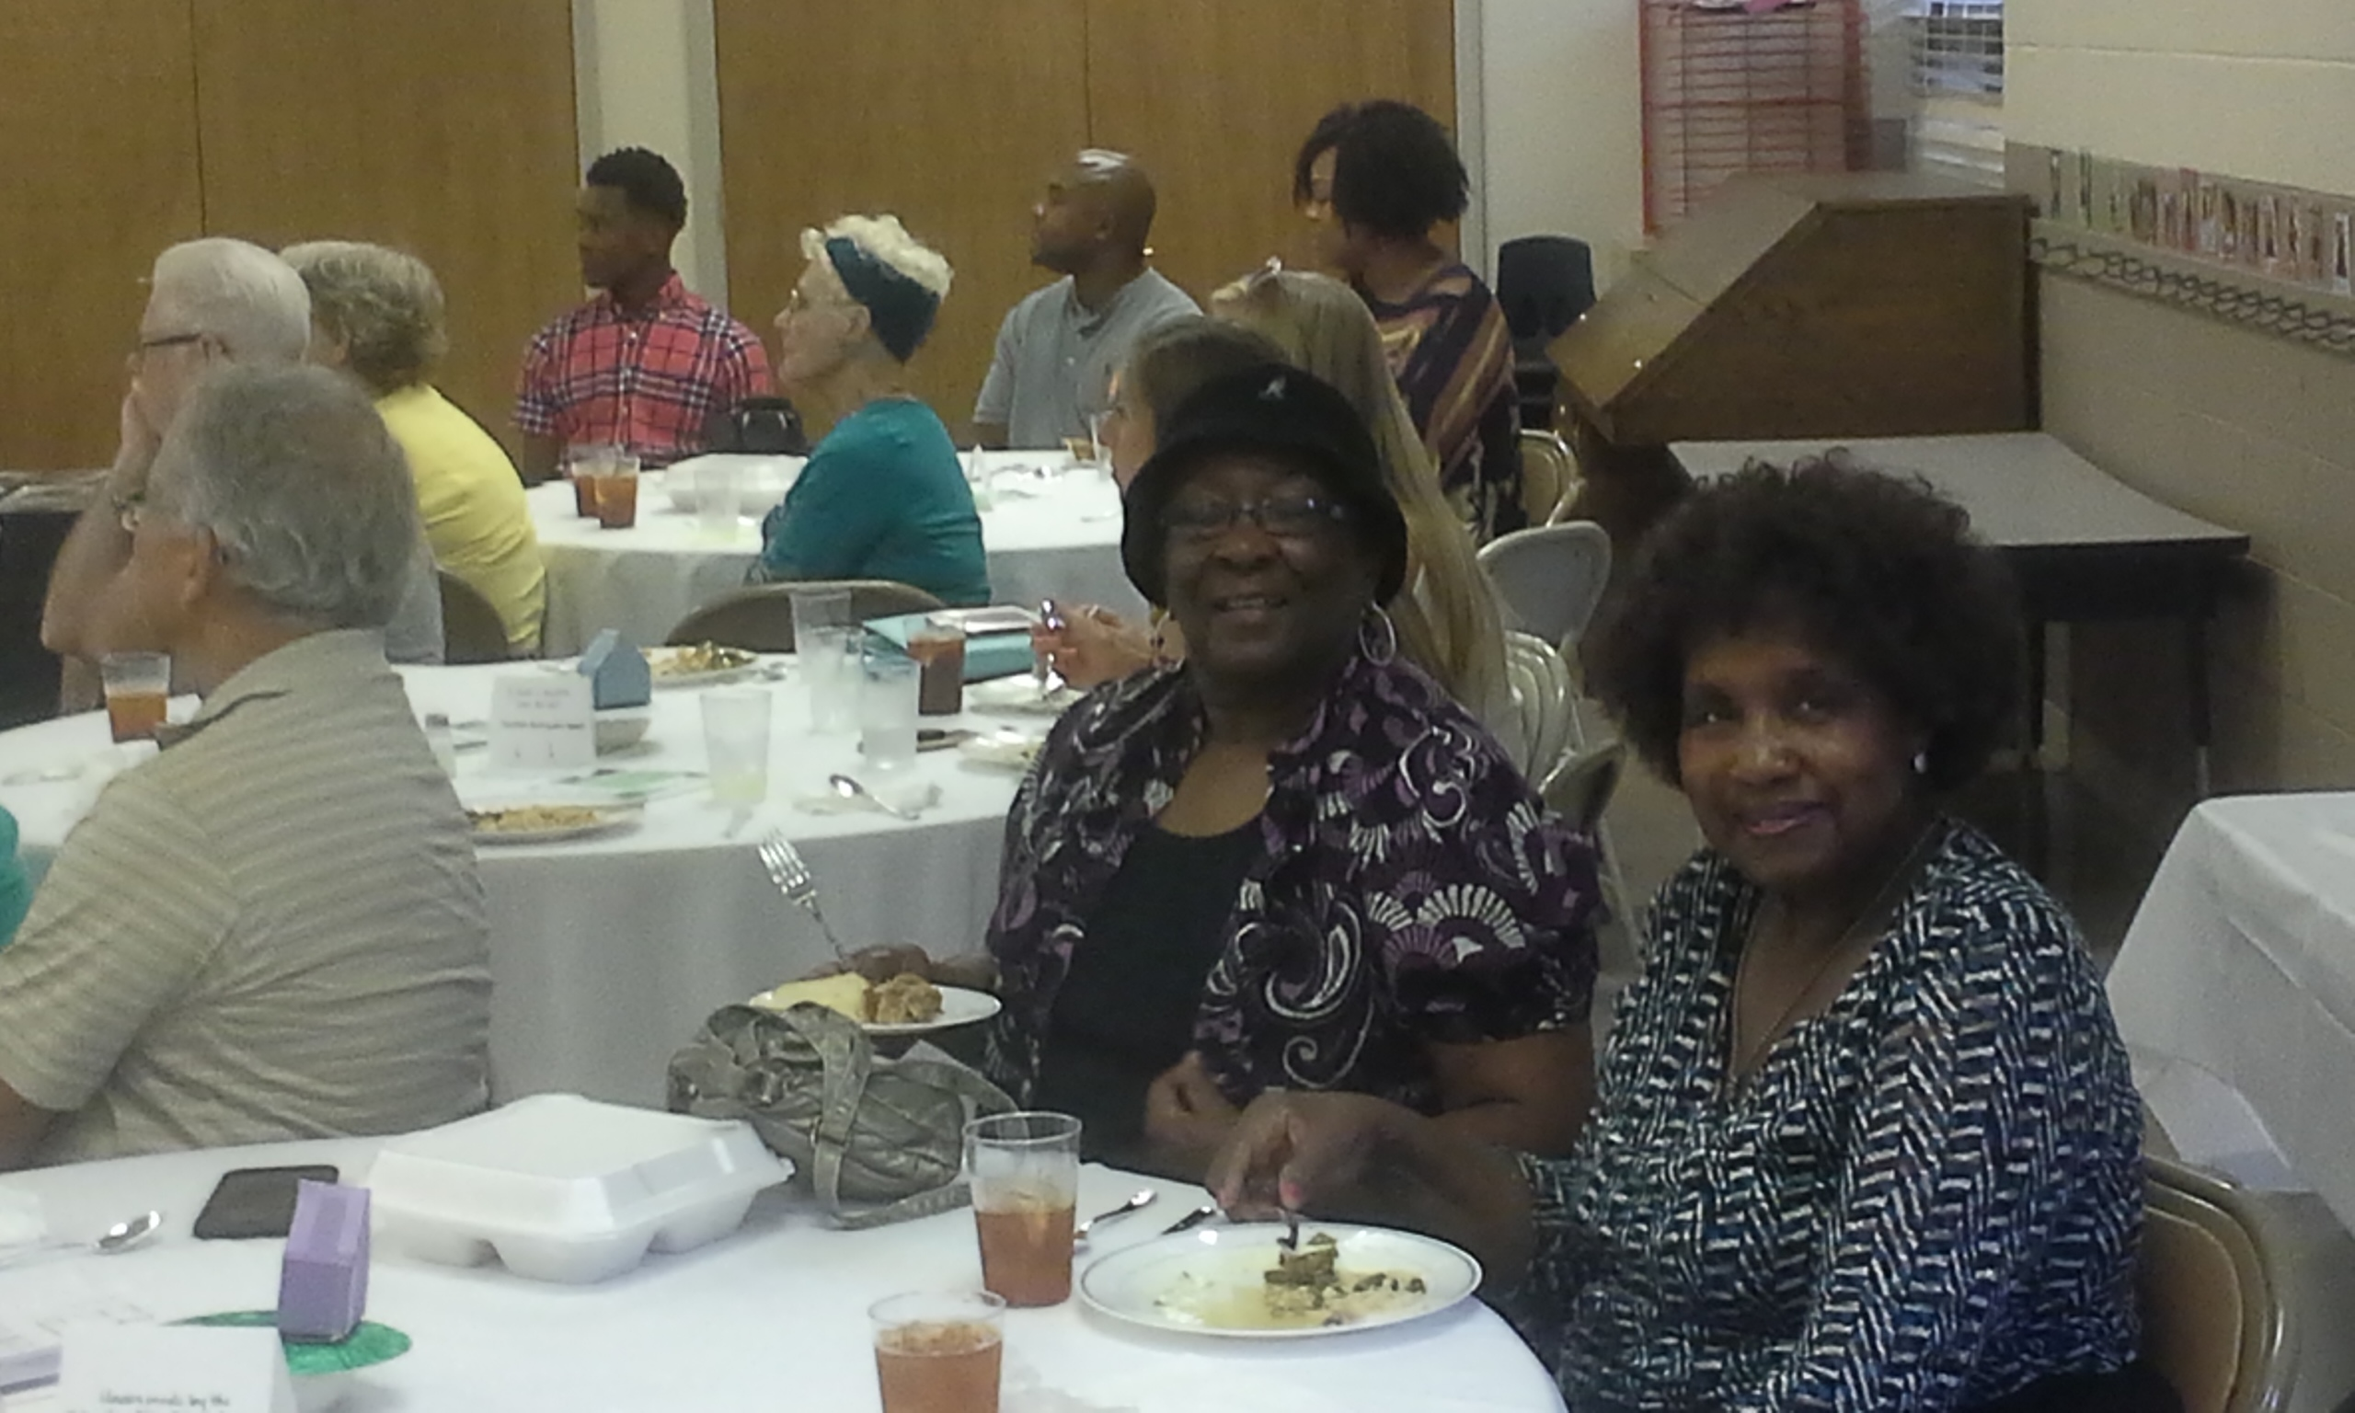
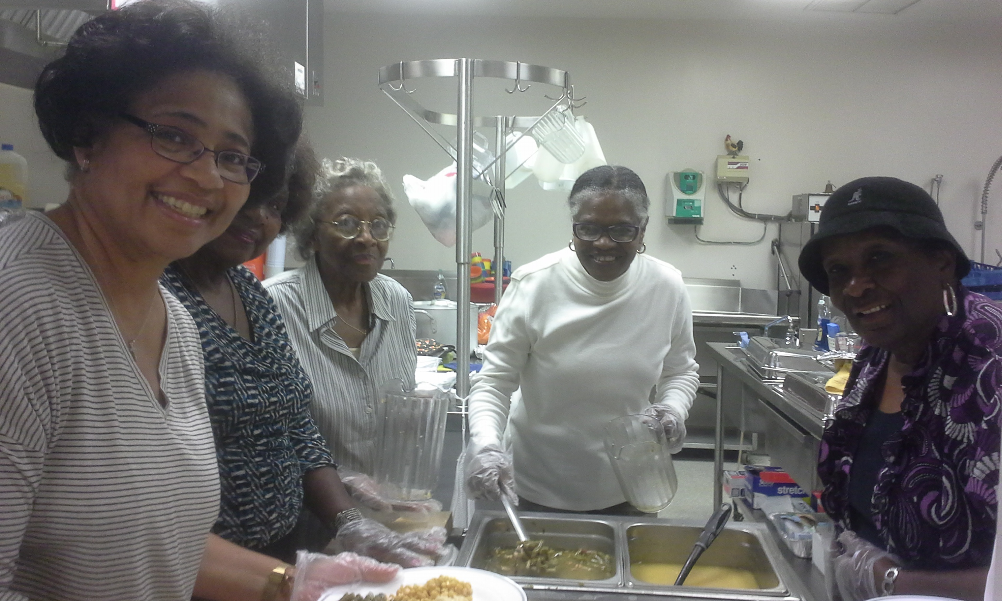

Members volunteer at Tiny House supper to raise funds to support new residents in Tiny House communities with their transportation needs and life’s essentials. The event brought awareness to the Tiny House Community and raised a total of $2,128.50, which exceeded its $2,000.00 goal. Pictured standing are: Sharon Smiley, Annie Purcell, Marie Martin, Linda Russell and Linda Adams. Members shown seated are Linda Adams and Annie Purcell.

Health Fair Scheduled
Saint James, in partnership with Nurse B, is sponsoring a Community Health Fair on Saturday, October 6, between 10:00 am and 2:00 pm at the Hayes Taylor YMCA. Come out, meet the vendors and learn what resources are available to you. Interested persons should contact Nurse “B”, Elder Marie Martin or Elder Sharon Smiley for more information. Be the best YOU, you can be!!!

Greater Greensboro Crop Hunger Walk
The 38th annual Crop Hunger Walk for Greater Greensboro will be held on Sunday, October 14, at the Greensboro Coliseum complex. If you are interested in being a Team Captain for Saint James this year, please contact Elder Sharon Smiley. Contributions to the Crop Hunger Walk should be made payable to Saint James Presbyterian Church with Crop Walk in the memo section of your check. Help stomp out both local and global hunger - one step at a time!
STEWARDSHIP Monthly collection and stewardship opportunities.

2018 Stewardship!

Thank you Saint James for your generous offerings received in the month of September. We missed our goal by $4,969.42. We ask that all members prayerfully consider their giving abilities so that we are able to meet our monthly operations budget. With your help and faith in God we are confident that Saint James will continue to be a beacon of light in the community and in the world.

Elders Karen & Jerry

September 2018 Collection Report
Goal: $7,497.00 each Sunday/ $32,487.00 per month

09/02/2018 | Worship Service | $6,372.65
09/09/2018 | Worship Service | $5,060.13
09/16/2018 | Worship Service | No Service
09/23/2018 | Worship Service | $8,677.00
09/30/2018 | Worship Service | $6,194.00
 | PayPal | $1,213.80
Total |  | $27,517.58
Missed Goal By |  | -$4,969.42

Upcoming Events

Guilford County Board of Elections: One-Stop Early Voting Schedule
November 6, 2018 General Elections

Early Voting will begin on Wednesday, October 17, 2018 and it will end on Saturday, November 3, 2018. Below you will find a list of polling places and the dates and times they will be open for voting.

Open: Wednesday, October 17 – Friday, October 19, from 8:00 am – 5:00 pm
Monday, October 22 – Friday, October 26, from 8:00 am – 5:00 pm
Monday, October 29 – Friday, November 2, from 8:00 am – 5:00 pm
Saturday, November 3, from 8:00 am – 1:00 pm

1. Old Courthouse – Blue Room, First Floor, 301 W. Market St, Greensboro
2. Washington Terrace Park, 101 Gordon St, High Point

Open: Wednesday, October 17 – Friday, October 19, from 7:00 am – 7:00 pm
Monday, October 22 – Friday, October 26, from 7:00 am – 7:00 pm
Monday, October 29 – Friday, November 2, from 7:00 am – 7:00 pm
Souls to the Polls - Sunday, October 28, from 12:00 pm – 5:00 pm
Saturday, November 3, from 8:00 am – 1:00 pm

3. Ag Center (Barn), 3309 Burlington Rd, Greensboro (Saint James Souls to the Polls)
4. Brown Recreation Center, 302 E. Vandalia Rd, Greensboro
5. Bur-Mil Club, 5834 Bur-Mil Club Rd, Greensboro
6. Craft Recreation Center, 3911 Yanceyville St, Greensboro
7. Deep River Recreation Center, 1529 Skeet Club Rd, High Point
8. Jamestown Town Hall, 301 E. Main St, Jamestown
9. Leonard Recreation Center, 6324 Ballinger Rd, Greensboro

Election Day Voting will take place on Tuesday, November 6, from 6:30 am – 7:30 pm at your assigned precinct.

For more information regarding the election please visit www.guilfordelections.org or call: Greensboro – 336.641.3836
High Point – 336.641.7895
VOLUNTEER We are busy serving each other – Join Us!

The Audio/Sound Ministry which is responsible for enhancing the sound generated during Sunday services, as well as all other special services, is actively seeking new members. Our major responsibilities revolve around using the soundboard to maximize the quality of each microphone output and to record all applicable parts of the service.

The Evangelism Team is seeking volunteers. Do You Have Creativity, a Great Smile, Willingness to Speak to Strangers and a Desire to Share God's Love? Join the Evangelism Team! Men and women of all ages are needed as we build our team to reach out to those who are yet to come. Sign up by sending your name, email and phone number to: lhawkins2011@gmail.com

Faith Point Fellowship Board (formerly Campus Ministry) is looking for committed persons who enjoy working with and supporting college students and young adults. Contact: Elder Paula Pierce at 443-253-7391.

Handbell Choir Do you want to bring out that hidden talent to play in a choir? If so, the Handbell Choir would like to welcome you on board. The group plays from five to seven times a year for church services. Members may also have the opportunity to perform in a recital as well as in schools.

Nursery Volunteers are needed to serve in the Nursery at least one Sunday service per month. To inquire about this opportunity, please see Elders Paula Graves and Channelle James or the church office.

Office Volunteers The church office is looking for willing to be trained volunteers to manage phones, proofread/edit church publications, or offer relief to the Office Manager during breaks and lunches. Volunteers must be willing to answer phones and be able to share the love of God with the community. If you are interested, please call the Church Office.

Outreach Ministry Volunteers are needed to serve meals at the Greensboro Urban Ministry, to drive senior adults to doctor’s visits via the Senior Wheels program.

Ushers are in short supply. If you have any experience with ushering or are willing to learn please contact Deacon Annetrice Hewitt or the Church Office. We would love to see your smiling face when we enter the church for worship.

WEEKLY CHURCH SCHEDULE A general schedule of activities

Sundays
8:00 am Express Service
9:15 am Free Congregational Nurse
9:30 am Continental Breakfast
11:00 am Morning Worship Service
12:30 pm 2nd Sundays
Monthly Trustee Meeting
3:00 pm Message and A Meal
Free Hot Meal & Health Information

Mondays
10:00 am Monday Morning Bible Study
6:00 pm 3rd Monday – Stephen Ministry
6:00 pm Inspirational Ensemble
7:00 pm New Generation Praise Team

Tuesdays
2:00 pm Golden Rays Exercise Group
6:30 pm 2nd Tuesdays
Monthly Elders’ Meeting
6:30 pm 3rd Tuesdays
Monthly Deacon Meeting

Wednesdays
12:30 pm Mid-Week Prayer Service
7:00 pm 1st Wednesdays
Financial Management Team

Thursdays
2:00 pm Golden Rays Exercise Group
6:15 pm Faith Point Fellowship

Fridays
No Scheduled activities

Saturdays
9:00 am 3rd Saturdays
Presbyterian Men’s Meeting & Breakfast

KIDS KORNER Bible Activities for youth. Weeks 1-2
KIDS KORNER Bible Activities for youth. Week 3-4

NOTES
________________________________________________________________________________________________________________________________________________________________________________________________________________________________________________________________________________________________________________________________________________________________________________________________________________________________________________________________________________________________________________________________________________________________________________________________________________________________________________________________________________________________________________________________________________________________________________________________________________________________________________________________________________________________________________________________________________________________________________________________________________________
___________________________________________________________________________________________________________________________
NOTES
________________________________________________________________________________________________________________________________________________________________________________________________________________________________________________________________________________________________________________________________________________________________________________________________________________________________________________________________________________________________________________________________________________________________________________________________________________________________________________________________________________________________________________________________________________________________________________________________________________________________________________________________________________________________________________________________________________________________________________________________________________________
___________________________________________________________________________________________________________________________
NOTES
________________________________________________________________________________________________________________________________________________________________________________________________________________________________________________________________________________________________________________________________________________________________________________________________________________________________________________________________________________________________________________________________________________________________________________________________________________________________________________________________________________________________________________________________________________________________________________________________________________________________________________________________________________________________________________________________________________________________________________________________________________________
___________________________________________________________________________________________________________________________
NOTES
________________________________________________________________________________________________________________________________________________________________________________________________________________________________________________________________________________________________________________________________________________________________________________________________________________________________________________________________________________________________________________________________________________________________________________________________________________________________________________________________________________________________________________________________________________________________________________________________________________________________________________________________________________________________________________________________________________________________________________________________________________________
___________________________________________________________________________________________________________________________
